LAB MANUAL OF

COMPUTER ORGANIZATION
AND
ARCHITECTURE
ETCS 260



Maharaja Agrasen Institute of Technology, PSP area,
Sector – 22, Rohini, New Delhi – 110085
( Affiliated to Guru Gobind Singh Indraprastha University, New Delhi )

MAHARAJA AGRASEN INSTITUTE OF TECHNOLOGY
VISION
To nurture young minds in a learning environment of high academic value and imbibe spiritual and ethical values with technological and management competence.
MISSION
The Institute shall endeavor to incorporate the following basic missions in the teaching methodology:
Engineering Hardware – Software Symbiosis
Practical exercises in all Engineering and Management disciplines shall be carried out by Hardware equipment as well as the related software enabling deeper understanding of basic concepts and encouraging inquisitive nature.
Life – Long Learning
The Institute strives to match technological advancements and encourage students to keep updating their knowledge for enhancing their skills and inculcating their habit of continuous learning.
Liberalization and Globalization
The Institute endeavors to enhance technical and management skills of students so that they are intellectually capable and competent professionals with Industrial Aptitude to face the challenges of globalization.
Diversification
The Engineering, Technology and Management disciplines have diverse fields of studies with different attributes. The aim is to create a synergy of the above attributes by encouraging analytical thinking.
Digitization of Learning Processes
The Institute provides seamless opportunities for innovative learning in all Engineering and Management disciplines through digitization of learning processes using analysis, synthesis, simulation, graphics, tutorials and related tools to create a platform for multi-disciplinary approach.
Entrepreneurship
The Institute strives to develop potential Engineers and Managers by enhancing their skills and research capabilities so that they become successful entrepreneurs and responsible citizens.

MAHARAJA AGRASEN INSTITUTE OF TECHNOLOGY

COMPUTER SCIENCE & ENGINEERING DEPARTMENT

VISION
To Produce “Critical thinkers of Innovative Technology”

MISSION
To provide an excellent learning environment across the computer science discipline to inculcate professional behavior, strong ethical values, innovative research capabilities and leadership abilities which enable them to become successful entrepreneurs in this globalized world.
- To nurture an excellent learning environment that helps students to enhance their problem solving skills and to prepare students to be lifelong learners by offering a solid theoretical foundation with applied computing experiences and educating them about their professional, and ethical responsibilities.
- To establish Industry-Institute Interaction, making students ready for the industrial environment and be successful in their professional lives.
- To promote research activities in the emerging areas of technology convergence.
- To build engineers who can look into technical aspects of an engineering solution thereby setting a ground for producing successful entrepreneur.
INDEX OF THE CONTENTS
- Introduction to the lab
- Lab Requirements (details of H/W & S/W to be used)
- List of Experiments as per GGSIPU
- List of experiments beyond the syllabus
- Format of the lab record to be prepared by the students.
- Marking scheme for the Practical Exam
- Instructions for each Lab Experiment
Appendix 1
Appendix 2
Appendix 3

- INTRODUCTION TO THE LAB

Lab Objective

To understand the basic organization of computer system including concept of memory, addressing, stack implementation in memory, register size and data handling using 8085 assembly instruction code and programming techniques. Objective of the lab is that the students are able to write an assembly code using mnemonics for the 8085 microprocessor.

Course Outcomes

At the end of the course, a student will be able to:
CO.260.1:Work efficiently on the simulator GNU sim8085 and will also be able to identify the basic elements and architecture of 8085.
CO.260.2: Analyze the basic instruction set of 8085 microprocessor.
CO.260.3: Write an assembly language code dealing with the data transfers within the registers, memory and the stack.
CO.260.4: Write an assembly language code using the arithmetic instructions of 8085 microprocessor instruction set to solve various problems.
CO.260.5: Write an assembly language code to solve various problems using logical Instructions of 8085 microprocessor instruction set.
CO.260.6: Write an assembly language code to solve various problems using branching Instruction of 8085 microprocessor instruction set.

ARCHITECTURE OF MICROPROCESSOR 8085

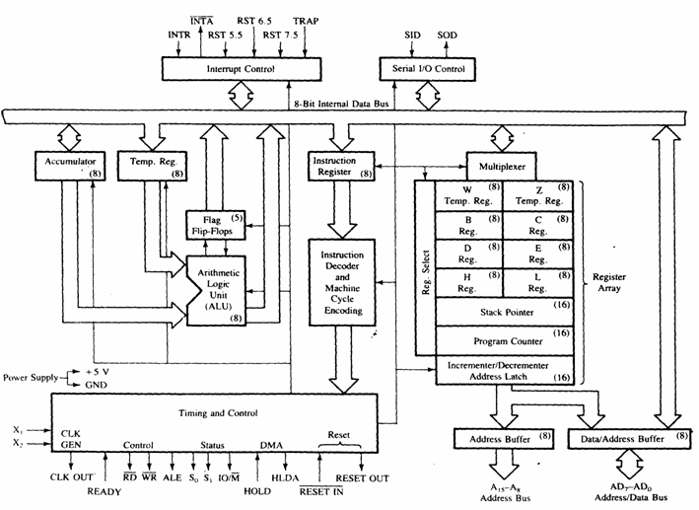
.

List of registers used in 8085 to perform various operations:

Accumulator:-It is a 8-bit register which is used to perform arithmetical and logical operation. It stores the output of any operation. It also works as registers for i/o accesses.
It can be one of the operand in the instruction.
Temporary Register:-It is a 8-bit register which is used to hold the data on which the accumulator is computing operation. It is also called as operand register because it provides operands to ALU.
Registers:-These are general purposes registers. Microprocessor consists 6 general purpose registers of 8-bit each named as B,C,D,E,H and L. Generally theses registers are not used for storing the data permanently. It carries the 8-bits data. These are used only during the execution of the instructions.
These registers can also be used to carry the 16 bits data by making the pair of 2 registers. The valid register pairs available are BC,DE HL. We cannot use other pairs except BC,DEand HL. These registers are programmed by user.

Flag Registers:-It consists of 5 flip flop which changes its status according to the result stored in an accumulator. It is also known as status registers. It is connected to the ALU.
There are five flip-flops in the flag register are as follows:
The bit position of the flip flop in flag register is:

All of the three flip flop set and reset according to the stored result in the accumulator.
1.Sign- If D7 of the result is 1 then sign flag is set otherwise reset. As we know that a number on the D7 always desides the sign of the number.
if D7 is 1: the number is negative.
if D7 is 0: the number is positive.
2.Zeros(Z)-If the result stored in an accumulator is zero then this flip flop is set as 1 otherwise it is reset and also if the result of any arithmetic or logical operation is zero its set as 1( The result of this operation can be in any registers).
3.Auxiliary carry(AC)-If any carry goes from D3 to D4 in the output then it is set otherwise it is reset.
4.Parity(P)-If the no of 1's is even in the output stored in the accumulator then it is set otherwise it is reset for the odd.
5.Carry(C)-If the result stored in an accumulator generates a carry in its final output then it is set otherwise it is reset.
6.Instruction registers(IR):-It is a 8-bit register. When an instruction is fetched from memory then it is stored in this register.

Description of other components of 8085:
Instruction Decoder: - Instruction decoder identifies the instructions. It takes the information from instruction register and decodes the instruction to be performed.
Program Counter:-It is a 16 bit register used as memory pointer. It stores the memory address of the next instruction to be executed. So we can say that this register is used to sequencing the program. Generally the memory has 16 bit addresses so that it has 16 bit memory.
The program counter is set to 0000H.
Stack Pointer:-It is also a 16 bit register used as memory pointer. It points to the memory location called stack. Generally stack is a reserved portion of memory where information can be stores or taken back together.
Timing and Control Unit:-It provides timing and control signal to the microprocessor to perform the various operation. It has three control signals. It controls all external and internal circuits. It operates with reference to clock signal. It synchronizes all the data transfers.
There are three control signal:
1.ALE-Airthmetic Latch Enable, It provides control signal to synchronize the components of microprocessor.
2.RD- This is active low used for reading operation.
3.WR-This is active low used for writing operation.
There are three status signal used in microprocessor S0, S1 and IO/M. It changes its status according the provided input to these pins.
Serial Input Output Control-There are two pins in this unit. This unit is used for serial data communication.
Interrupt Unit-There are 6 interrupt pins in this unit. Generally an external hardware is connected to these pins. These pins provide interrupt signal sent by external hardware to microprocessor and microprocessor sends acknowledgement for receiving the interrupt signal. Generally INTA is used for acknowledgement.

INTRODUCTION TO GNU Simulator 8085

8085 simulator is software on which instructions are executed by writing the programs in assembly language.
- GNUSim8085 is a 8085 microprocessor simulator with following features.
- A simple editor component with syntax highlighting.
- A keypad to input assembly language instructions with appropriate arguments.
- Easy view of register contents.
- Easy view of flag contents.
- Hexadecimal to Decimal converter.
- View of stack, memory and I/O contents.
- Support for breakpoints for programming debugging.
- Stepwise program execution.
- One click conversion of assembly program to opcode listing.
- Printing support (known not to work well on Windows).
- UI translated in various languages.

Writing a program in assembly language:-

Format of the instruction is as follows:-

Label | Operation | Operands | Comments
Its optional | Necessary | Necessary | Its optional

A basic assembly program consists of 4 parts.
- Labels
- Operations :- these operations can be specified as
Machine operations (mnemonics):- used to define operations in the form of opcode as mention in the instruction set of microprocessor 8085.
Pseudo operations (like preprocessor in C):- these are assembly directives.
- Operands
- Comments

In addition, you have constants in an assembly program. Unless otherwise specified, a constant which is always numeric is in decimal form. If appended with a character h it is assumed to be in hexadecimal form. If a hex constant starts with an alpha-char don't forget to include the number 0 in the beginning, since that will help the assembler to differentiate between a label and a constant.
Labels:-
When given to any particular instruction/data in a program, takes the address of that instruction or data as its value. But it has different meaning when given to EQU directive. Then it takes the operand of EQU as its value. Labels must always be placed in the first column and must be followed by an instruction (no empty line). Labels must be followed by a : (colon), to differentiate it from other tokens.
Operations:-
As mentioned above the operations can be specified in two ways that are mnemonics and pseudo operation.
Pseudo operations can be defined by using following directives:-
There are only 3 directives currently available in our assembly language.
- DB - define byte ( 8 bits )
- DS - define size (no. of bytes)
- EQU - like minimalistic #define in C
DB is used to define space for an array of values specified by comma separated list. And the label (if given to the beginning of DB) is assigned the address of the first data item.

DS is used to define the specified number of bytes to be assigned and initialize them to zero. To access each byte you can use the + or -operator along with label.

EQU behaves similar to #define in C. But it is simple. It can be used to give names only to numeric constants. Nesting of EQU is not allowed. You can use EQU only in operands for pseudo ops and mnemonics.
Operands:-
Operands are specified according to the user. The register set specified in the architecture of 8085 (A, B, C, D, H and L) are used to access and store data. These registers are specified as operand. In case of accessing data or storing data in the memory ‘m’ is specified as an operand and the address of this memory location is taken from the HL pair (data in HL pair)

HOW TO START WITH GNU Simulator 8085

Step1: open GNU Sim 8085 above window will open. Now click on close button highlighted in the above screen shot.

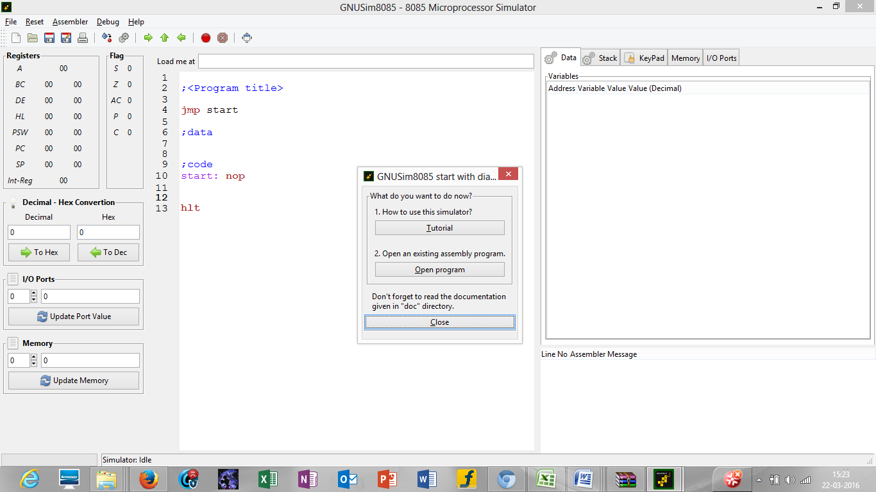

Figure 1

Step2: start writing the code after start: nop in load me at 10 that is at load me at 11.

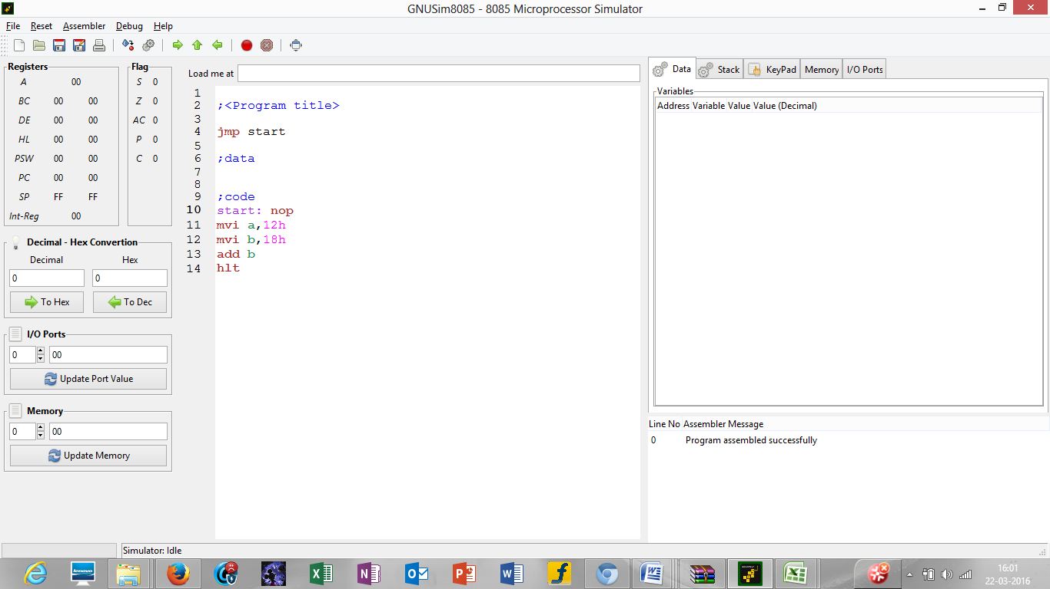

Figure 2

Step 3: click on reset and reset all the registers by clicking on reset all.

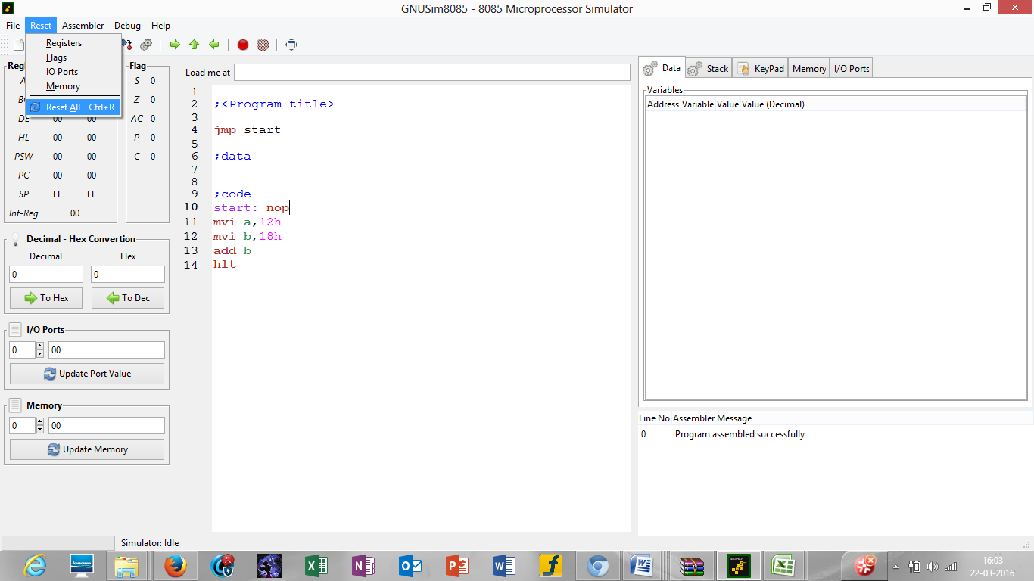

Figure 3

Step 4: click on the highlighted button to execute the code

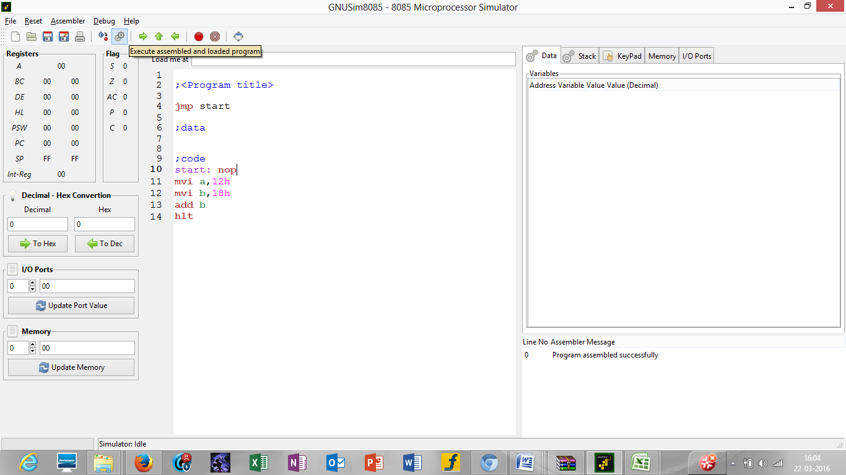

Figure 4

Step 5: after you execute the code mention the name your program by writing the name in the name section as mentioned in the screen shot in picture 5 and the drive where you want to save it. After that click on save.

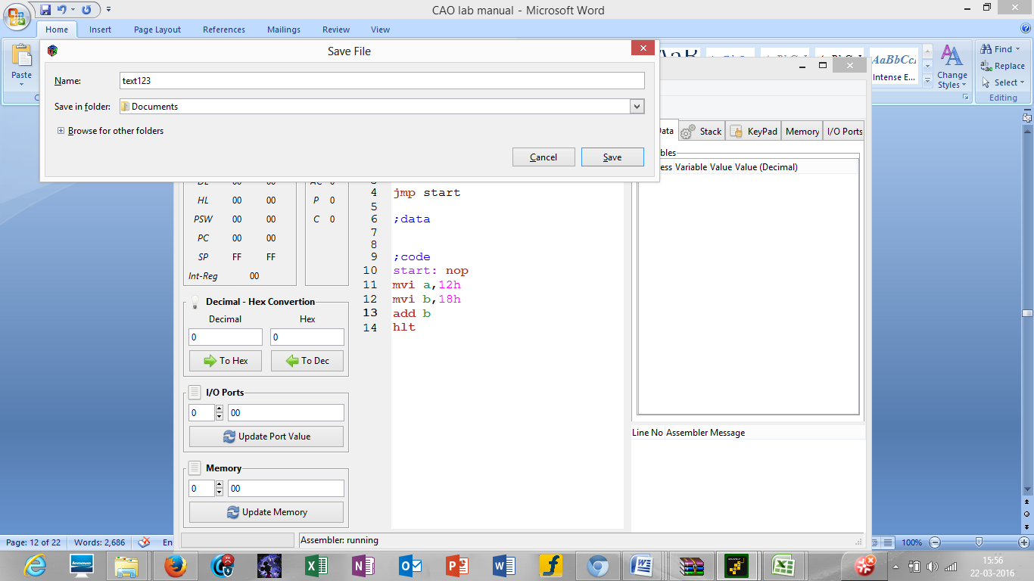

Figure 5

Step 6: after this you will see the result of the instructions in the respective registers as seen in the above picture 6.

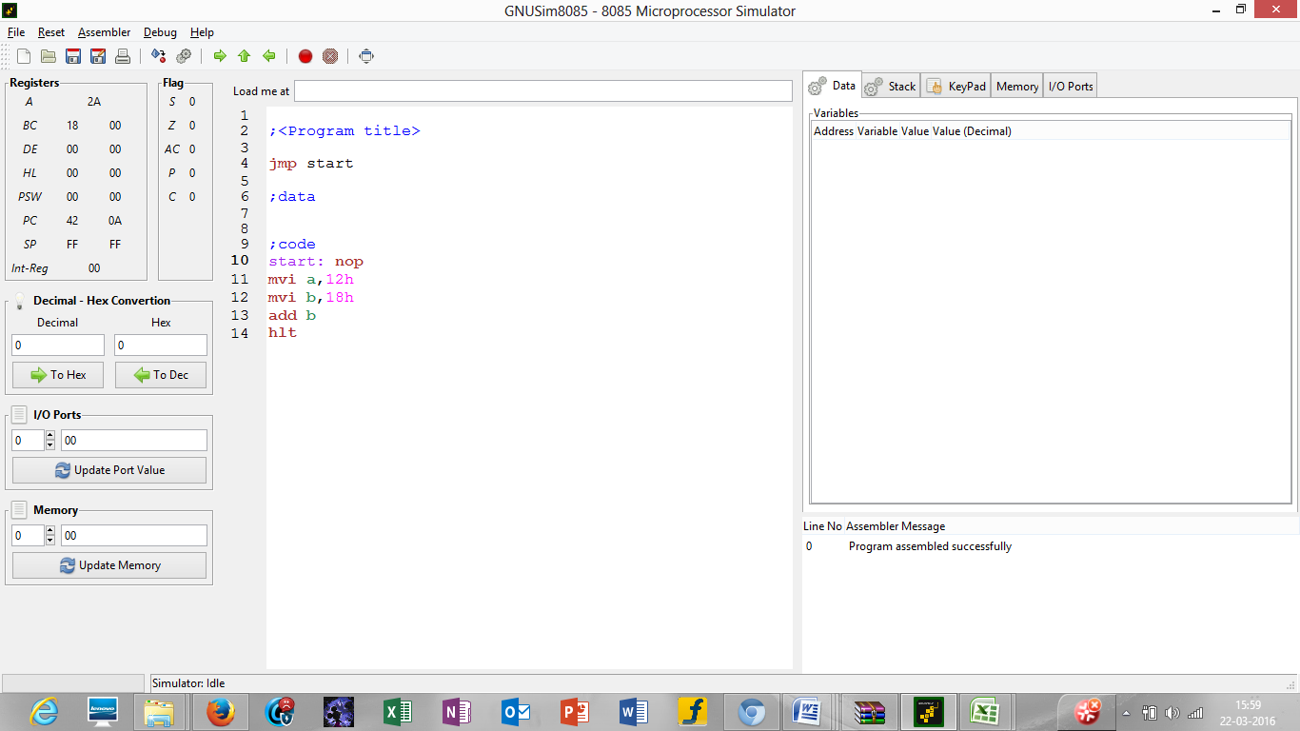

Figure 6

2. Lab requirements (details of H/W & S/W to be used)
GNU Sim 8085 is an open source and is platform independent.
General requirements are:
Hardware Detail | Intel i3/C2D Processor/2 GB RAM/500GB HDD/MB/Lan Card/  Key Board/ Mouse/CD Drive/15” Color Monitor/ UPS 24 Nos
 | LaserJet Printer 1 No
Software Detail
Operating system : Fedora Linux

Software : GNU sim 8085

3. LIST OF EXPERIMENTS
(According to G.G.S.I.P.U)

Paper Code: ETCS 254 P C

Paper: Computer Organization and Architecture 3 2

List of Experiments

- To draw and explain
    - Block diagram and pin diagram of 8085.
    - Instruction set of 8085.
- Write a program to perform:
    - Addition of two 8 bit numbers without carry.
    - Addition of two 8 bit numbers with carry. Study the complete instruction set of 8085
- Write a program to perform:
    - Subtraction of two 8 bit numbers without borrows.
    - Subtraction of two 8 bit numbers with borrows.
- Write a program to find 1‘s complement of an 8 bit number.
- Write a program to find 2‘s complement of an 8 bit number.
- Write a program to perform Multiplication of two 8 bit numbers.
- Write a program to find to find the smallest and largest number from the given series.
- Write a program to find sum of series of n consecutive numbers.
- Write a program to find factorial of a number.
- Write a program to reverse an 8-bit number.
- Write a program to sort array in ascending/ descending order.
- Write a program to perform division of two 8 bit numbers.
NOTE: - At least 8 Experiments from the syllabus must be done in the semester

- LIST OF EXPERIMENTS
(Beyond G.G.S.I.P.U)

PaperCode:ETCS260 P C

Paper: Computer Organization and Architecture 3 2

List of Experiments

- Write the working of GNUsim8085.
- Write an assembly language code in GNUsim8085 to store numbers in reverse order in memory location.
- Write an assembly language code in GNUsim8085 to add two 16 bit numbers without using lxi instruction.
- Write an assembly code to multiply two 8 bit numbers without shifting.
- Write an assembly code to the count the number of 1's
- Write an assembly code to multiply two 8 bit numbers and store using shifting
- Write an assembly code to add ‘n’ 8 bit numbers, sum may be 8 bits or more
- Write an assembly code to find the sum of n numbers stored in continuous locations without carry & add with carry

- FORMAT OF THE LAB RECORD TO BE PREPARED BY THE STUDENTS

The front page of the lab record prepared by the students should have a cover page as displayed below.

NAME OF THE LAB
Paper Code
Font should be (Size 20”, italics bold, Times New Roman)

Faculty name Student name
Roll No.:
Semester:

Font should be (12”, Times Roman)



Maharaja Agrasen Institute of Technology, PSP Area,
Sector – 22, Rohini, New Delhi – 110085
Font should be (18”, Times Roman)
The second page in the record should be the index as displayed below.

INDEX

Exp. no | Experiment Name | Date of performance | Date of checking | Remarks | Marks  (10)

- MARKING SCHEME FOR THE PRACTICAL EXAMS

There will be two practical exams in each semester.

- Internal Practical Exam
- External Practical Exam

INTERNAL PRACTICAL EXAM

It is taken by the respective faculty of the batch.

MARKING SCHEME FOR THIS EXAM IS:

Total Marks: 40

Division of 10 marks per practical is as follows:

 | Rubrics for : Laboratory (General)
Sr No. | Experiment Component (LAC) | Max. Marks | Grading Rubrics
Sr No. | Experiment Component (LAC) | Max. Marks | 2 marks | 1 mark
1 | Practical Performance | 2 | Completeness of practical, exhibits proficiency in using different types of inputs. | Incomplete practical, unformatted, lacks comments, Demonstrates no proficiency.
2 | Output and Validation | 2 | Output is free of errors and output is obtained. Demonstrates excellent understanding of the concepts relevant to the experiment. | Output contains few logical errors and/or no output is obtained. Demonstrates partial understanding of the concepts relevant to the experiment.
3 | Attendance and Viva Questions Answered | 4 | 1. Four marks for answering more than 75% questions.  2. Two marks for answering more then 50% questions.  3. One mark for answering less then 50% questions.
4 | Timely Submission of Lab Record | 2 | On time submission | Late submission

Each experiment will be evaluated out of 10 marks. At the end of the semester average of 8 best performed practical will be considered as marks out of 40.
EXTERNAL PRACTICAL EXAM

It is taken by the concerned lecturer of the batch and by an external examiner. In this exam student needs to perform the experiment allotted at the time of the examination, a sheet will be given to the student in which some details asked by the examiner needs to be written and at the last viva will be taken by the external examiner.

MARKING SCHEME FOR THIS EXAM IS:

Total Marks: 60

Division of 60 marks is as follows

  - Sheet filled by the student: 20

  - Viva Voice: 15

  - Experiment performance: 15

  - File submitted: 10

NOTE:

- Internal marks + External marks = Total marks given to the students
(40 marks) (60 marks) (100 marks)

- Experiments given to perform can be from any section of the lab.

- Instructions for each Lab Experiment

Lab files have to be a hard bound file, in which one side is ruled and one side is plain.
The experiments performed have to be hand written, outputs can be printouts.

Samples of how to write experiment in the lab files:

According to GGSIPU

Experiment 1

Aim:To draw and explain
i. Block diagram and pin diagram of 8085.
ii. Instruction set of 8085.

Theory:

Well labeledarchitecture of 8085 and its pin diagram have to be drawn on the blank page.
Details of each component of the 8085 architecture and general information about GNU sim 8085 have to be explained on the ruled side page of the file.
Also write the complete instruction set of 8085 with details on the ruled page.
For the details of pin diagram 8085 micro-processor refer Appendix 1.
For the details of instruction set refer to Appendix 2.
For the details of GNU sim 8085 refer to the lab introduction given before in lab manual.

Procedure:

Here you have to write the steps of how to start working on GNU sim 8085.

Output:

Paste the screen shot of GNU sim simulator on the blank page as shown below:

Viva - Questions:

- What is the use of accumulator in the 8085 micro- processor?

- How can we store data in 8085 micro-processor?

- What is the use of GNU sim simulator ?

- How do we execute the assembly code in GNU sim 8085?

- How many types of registers are provided in the architecture of 8085?

- Explain the use of flag registers in the 8085 architecture.

Experiment 2

Aim:Write a program to perform:
i. Addition of two 8 bit numbers without carry.
ii. Addition of two 8 bit numbers with carry

Theory:

Write the various instructions used from the instruction set of 8085 on the ruled page.
For the set of instructions refer to Appendix 2.
Procedure:
Write down the corresponding assembly code using mnemonics on the ruled page.
Output:
On the blank page paste the screen shots of the line wise execution of each instruction written in mnemonics.

Viva Questions

- What is the syntax for writing an instruction in assembly code using mnemonics?

- Which language makes use of mnemonics instead of numeric op-codes & symbolic names for data locations instead of numeric address?

- The instruction format ‘register – register’ is of how much length?

- How will 8 bit data get stored in the HL pair?

Experiment 3

Aim: Write a program to perform:
i. Subtraction of two 8 bit numbers without borrows.
ii. Subtraction of two 8 bit numbers with borrows.

Theory:
Write the various instructions used from the instruction set of 8085 on the ruled page.
For the set of instructions refer to Appendix 2.

Procedure:
Write down the corresponding assembly code using mnemonics on the ruled page.

Output:
On the blank page paste the screen shots of the line wise execution of each instruction written in mnemonics.

Viva - Questions:
- Data transfer can take place between which storage places in 8085 micro-processor?

- What will the result of the following code when written in GNU sim 8085

MVI A, 5Ah
MVI B, 1Fh
ANA B
HLT

- Which instructions of 8085 microprocessor can be used if we need to store 45H into a register?

- MVI m, 30h. The address of the memory location will be taken from which registers.

Experiment 4

Aim:Write a program to find 1‘s complement of an 8 bit number.

Theory:
Write the various instructions used from the instruction set of 8085 on the ruled page.
For the set of instructions refer to Appendix 2.

Procedure:
Write down the corresponding assembly code using mnemonics on the ruled page.

Output:
On the blank page paste the screen shots of the line wise execution of each instruction written in mnemonics

Viva - Questions:

- Data transfer can take place between which storage places in 8085 micro-processor?

- What will be the result of the following code when written in GNU sim 8085

MVI A, 15h
MVI B, 83h
ADD B
HLT

- Which instruction is used to get the BCD addition result?

- The Carry flag is undefined after performing the __________operation.

Experiment 5

Aim: Write a program to find 2‘s complement of an 8 bit number.

Theory:
Write the various instructions used from the instruction set of 8085 on the ruled page.
For the set of instructions refer to Appendix 2.

Procedure:
Write down the corresponding assembly code using mnemonics on the ruled page.

Output:
On the blank page paste the screen shots of the line wise execution of each instruction written in mnemonics

Viva - Questions:
- Give the similarity and difference between LXI and MVI instruction.

- How does the data get stored when we use LXI instruction?

- How are negative numbers represented as data?

- (47)₁₀ + (68)₁₀ solve it using 2’s complement method.

Experiment 6

Aim: Write a program to perform Multiplication of two 8 bit numbers.

Theory:
List the various instructions in the instruction set of 8085 micro-processor used to implement this experiment on the ruled page.
For the sample code refer to the samples in the lab manual in Appendix 3.
For the set of instructions refer to Appendix2.
Procedure:
Write down an assembly code using mnemonics on the ruled page which includes all the required instruction from the instruction set of 8085.
Output:
On the blank page paste the screen shots of the line wise execution of each instruction written in mnemonics.

Viva - Questions:
- List any two logical instructions?

- What will the result of the following code when written in GNU sim 8085

MVI A, 5Ah
MVI B, 1Fh
ANA B
HLT

- Which logical instruction of 8085 microprocessor can be used if we need to compare the second byte with the contents of the accumulator?

- Explain the use of ORA logical instruction?

Experiment 7

Aim:Write a program to find to find the smallest and largest number from the given series.

Theory:
List the various instructions in the instruction set of 8085 micro-processor used to implement this experiment on the ruled page.
For the sample code refer to the samples in the lab manual in Appendix 3.
For the set of instructions refer to Appendix 2.
Procedure:
Write down an assembly code using mnemonics on the ruled page which includes all the required instruction from the instruction set of 8085.
Output:
On the blank page paste the screen shots of the line wise execution of each instruction written in mnemonics.

Viva - Questions:

- How does the carry flag work?

- Which instructions of 8085 microprocessor can be used if we need to decrement a register pair (DE) by 1?

- What will happen if we use INR m instruction?

- How can we accesses the data stored in contigious memory loaction?

Experiment 8

Aim: Write a program to find sum of series of n consecutive numbers.

Theory:
List the various instructions in the instruction set of 8085 micro-processor used to implement this experiment on the ruled page.
For the sample code refer to the samples in the lab manual in Appendix 3.
For the set of instructions refer to Appendix2.
Procedure:
Write down an assembly code using mnemonics on the ruled page which includes all the required instruction from the instruction set of 8085.
Output:
On the blank page paste the screen shots of the line wise execution of each instruction written in mnemonics.

Viva - Questions:

- List any three branching instructions?

- JMP instruction is of how many bits?

- What will be the status of the flag register when we use JPE jump instruction?

Experiment 9

Aim: Write a program to find factorial of a number.

Theory:
List the various instructions in the instruction set of 8085 micro-processor used to implement this experiment on the ruled page.
For the sample code refer to the samples in the lab manual in Appendix 3.
For the set of instructions refer to Appendix2.
Procedure:
Write down an assembly code using mnemonics on the ruled page which includes all the required instruction from the instruction set of 8085.
Output:
On the blank page paste the screen shots of the line wise execution of each instruction written in mnemonics.

Viva - Questions:
- How the status flag change while using JMP instruction (explain any five)?

- Which instruction is used to load the PC with the HL contents?

- What is the use of PC?

Experiment 10

Aim: Write a program to reverse an 8 bit number.

Theory:
List the various instructions in the instruction set of 8085 micro-processor used to implement this experiment on the ruled page.
For the sample code refer to the samples in the lab manual in Appendix 3.
For the set of instructions refer to Appendix2.
Procedure:
Write down an assembly code using mnemonics on the ruled page which includes all the required instruction from the instruction set of 8085.
Output:
On the blank page paste the screen shots of the line wise execution of each instruction written in mnemonics.

Viva - Questions:
- List the instructions from the instruction set of 8085 which work on immediate addressing mode?

- What is the significance of stack pointer?

- The data entered in the registers is in which number system. Is the data stored in the memory is of same number system as in registers?

- Define the various addressing modes.

Experiment 11

Aim: Write a program to sort array in ascending/ descending order.

Theory:
List the various instructions in the instruction set of 8085 micro-processor used to implement this experiment on the ruled page.
For the sample code refer to the samples in the lab manual in Appendix 3
For the set of instructions refer to Appendix2.
Procedure:
Write down an assembly code using mnemonics on the ruled page which includes all the required instruction from the instruction set of 8085.
Output:
On the blank page paste the screen shots of the line wise execution of each instruction written in mnemonics.

Viva - Questions:
- How do we define an array in mnemonics?

- Which instructions will be used to traverse an array?

- List the various micro-operations?

- Explain the term RTL.

Experiment 12

Aim: Write a program to perform division of two 8 bit numbers.

Theory:
List the various instructions in the instruction set of 8085 micro-processor used to implement this experiment on the ruled page.
For the sample code refer to the samples in Appendix 3.
For the set of instructions refer to Appendix2.
Procedure:
Write down an assembly code using mnemonics on the ruled page which includes all the required instruction from the instruction set of 8085.
Output:
On the blank page paste the screen shots of the line wise execution of each instruction written in mnemonics.

Viva - Questions:
- Define the micro-operations that are used to do multiplication and division?

- Explain the use of branching instructions?

- Show the corresponding RTL operations for arithmetic micro-operations?

- Explain the stack instructions of 8085 micro-processor.

APPENDIX 1

PIN DIAGRAM OF 8085

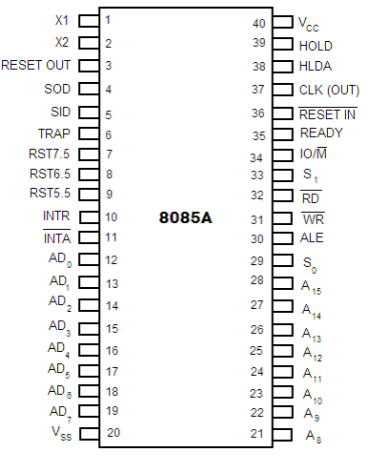
8085 Pin description
- Higher Order Address pins- A₁₅ – A₈
  - The address bus has 8 signal lines A8 – A15 which are unidirectional.
- Lower Order Address/ Data Pins- AD₇-AD₀
  - These are time multiplexed pins and are de-multiplexed using the pin ALE
  - So, the bits AD0 – AD7 are bi-directional and serve as A0 – A7 and D0 – D7 at the same time.
    - During the execution of the instruction, these lines carry the address bits during the early part, then during the late parts of the execution, they carry the 8 data bits.
  - In order to separate the address from the data, we can use a latch to save the value before the function of the bits changes.
- Control Pins – RD, WR
  - These are active low Read & Write pins
- Status Pins – ALE, IO/M (active low), S₁, S₀
  - ALE (Address Latch Enable)-Used to de-multiplex AD₇-AD₀
  - IO/M – Used to select I/O or Memory operation
  - S₁,S₀ – Denote the status of data on data bus

- Interrupt Pins – TRAP, RST7.5, RST 6.5, RST 5.5, INTR, INTA
  - These are hardware interrupts used to initiate an interrupt service routine stored at predefined locations of the system memory.
- Serial I/O pins – SID (Serial Input Data), SOD (Serial Output Data)
  - These pins are used to interface 8085 with a serial device.

- Clock Pins- X₁, X₂, CLK(OUT)
  - X₁, X₂– These are clock input pins. A crystal is connected between these pins such that f_{crystal}= 2f₈₀₈₅ where f_{crystal}= crystal frequency & f₈₀₈₅ = operating frequency of 8085
  - CLK(OUT) – This is an auxiliary clock output source
- Reset Pins – Reset In (active low), Reset Out
  - Reset In is used to reset 8085 whereas Reset Out can be used to reset other devices in the system
- DMA (Direct Memory Access) pins – HOLD, HLDA
  - These pins are used when data transfer is to be performed directly between an external device and the main memory of the system.
- Power Supply Pins – +V_{CC}, V_{SS}

APPENDIX 2

APPENDIX 3

Sample codes

Programs in gnusim8085

- ADDITION OF TWO NUMBERS STORED IN MEMORY

lxi h,8500h // LOADS THE H-L PAIR WITH THE VALUE 8500
mvi m, 24h // STORES THE DECIMAL EQIVALENT OF 24H INTO THE //LOCATION 8500
lda8500 // LOADS THE ACCUMULATOR WITH THE VALUE STORED AT //LOCATION 8500
movb,a //LOADS THE VALUE IN ACCUMULATOR TO THE REGISTER B
lxi h, 8501h // LOADS THE H-L PAIR WITH THE VALUE 8500
mvi m, 34h // STORES THE DECIMAL EQIVALENT OF 34H INTO THE //LOCATION 8501
lda 8501 // LOADS THE ACCUMULATOR WITH THE VALUE STORED AT //LOCATION 8501
add b //ADDS THE VALUES STORED IN THE REGISTER B AND THE //ACCUMULATOR
sta 8502 //STORES THE VALUE IN THE ACCUMULATOR IN THE //MEMORY LOCATION 8502
hlt

Sample Output:

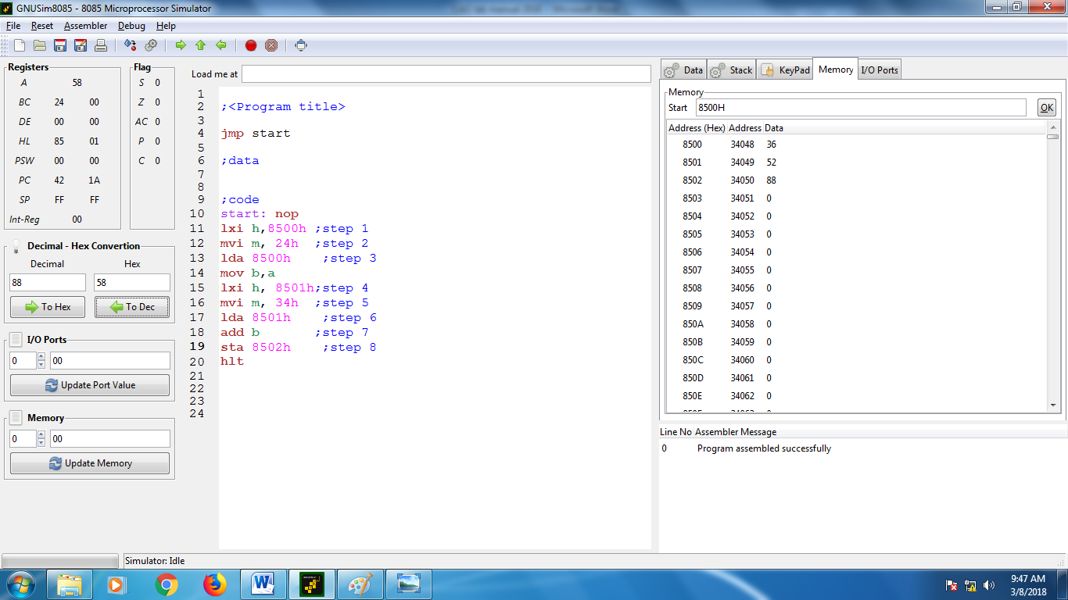

- ADDITION OF FOUR NUMBERS STORED IN THE CONSECUTIVE MEMORY LOCATIONS

lxi h,0400H // STORES THE VALUE 0400 IN H-L PAIR

mvi m,56h // STORES THE VALUE 56H IN THE MEMORY LOCATION 0400H

inx h //INCREMENTS THE H-L PAIR VALUE TO 04001H

mvi m,70h // STORES THE VALUE 70H IN THE MEMORY LOCATION 04001H

inx h //INCREMENTS THE H-L PAIR VALUE TO 04001H
mvi m,04h //LOADS THE MEMORY LOCATION 0400H WITH THE VALUE //04H
inx h //INCREMENTS THE H-L PAIR VALUE TO 04002
mvi m,03h // STORES THE VALUE 70H IN THE MEMORY LOCATION 04002H
mvi c,04h //LOADS THE REGISTER C WITH VALUE 04H
loop: mov b,m //LOADS THE REGISTER B WITH THE VALUE STORED IN //LOCATION 04002
add b //ADDS THE VALUE IN REGISTER B WITH THE VALUE IN //ACCUMULATOR
dcx h //DECREMENTS THE VALUE IN H-L PAIR TO 04001H
dcr c //DECREMENTS THE VALUE IN REGISTER C TO 3
jnz loop //CHECKS THE VALUE IN REGISTER C. IF ITS A NON ZERO //VALUE THE CONTROL GOES TO THE LABLE ‘loop‘, ELSE //CONTROL GOES TO THE NEXT STATEMENT

hlt

Sample Output:

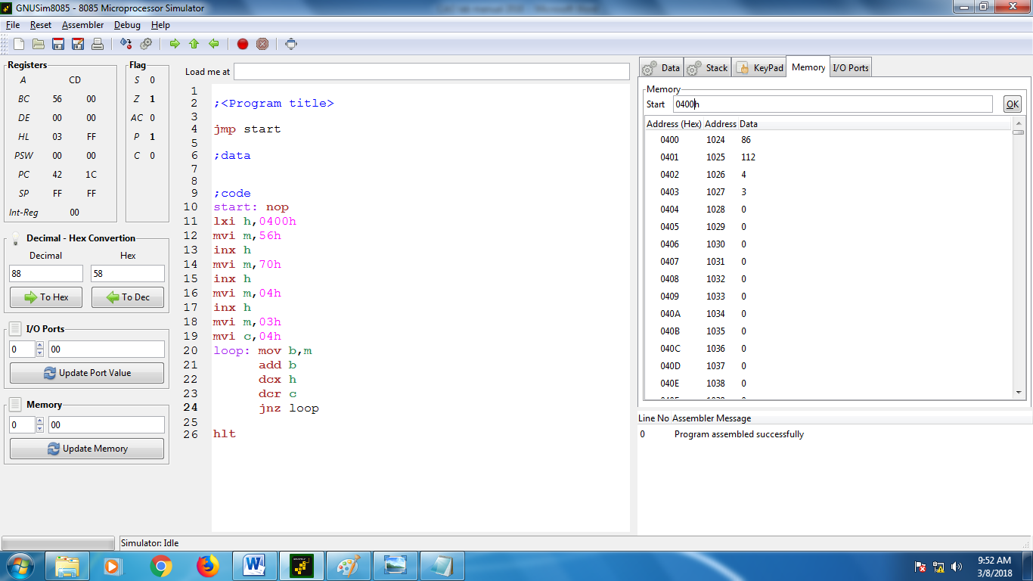

- REVERSING THE CONTENTS OF FOUR MEMORY LOCATIONS

lxi h, 4001h //H-L PAIR REGISTER IS LOADED WITH 4001H
mvi m, 45h //45H VALUE IS STORED AT LOCATION 4001H
inx h //VALUE IN H-L PAIR IS CHANGED TO 4002H
mvi m, 34h //34H VALUE IS STORED AT LOCATION 4002H
inx h //VALUE IN H-L PAIR IS CHANGED TO 4003H
mvi m, 25h //34H VALUE IS STORED AT LOCATION 4003H
inx h //VALUE IN H-L PAIR IS CHANGED TO 4004H
mvi m, 13h //13H VALUE IS STORED AT LOCATION 4004H
mvi c,04h //REGISTER C GETS LOADED WITH THE VALUE C
mov b,m //REGISTER B IS LOADED WITH THE VALUE //STORED AT LOCATION 4004H
dcx h //VALUE IN H-L PAIR IS DECREMENTED TO 4003H
mov c,m //CONTENTS OF MEMORY LOCATION 4003H ARE //LOADED TO REGISTER C
dcx h //VALUE IN H-L PAIR IS DECREMENTED TO 4002H

mov d,m //CONTENTS OF MEMORY LOCATION 4002H ARE //LOADED TO REGISTER D

dcx h //VALUE IN H-L PAIR IS DECREMENTED TO 4001H

mov e,m //CONTENTS OF MEMORY LOCATION 4001H ARE //LOADED TO REGISTER E
mov m,b //VALUE OF B IS STORED AT LOCATION 4001H
inx h //VALUE IN H-L PAIR IS INCREMENTED TO 4002H
mov m,c //CONTENTS OF REGISTER C ARE STORED IN //MEMORY LOCATION 4002H
inx h //VALUE IN H-L PAIR IS INCREMENTED TO 4003H

mov m,d //CONTENTS OF REGISTER D ARE STORED IN //MEMORY LOCATION 4003H

inx h //VALUE IN H-L PAIR IS INCREMENTED TO 4004H

mov m,e //CONTENTS OF REGISTER E ARE STORED IN //MEMORY LOCATION 4004H

hlt

Sample Output:

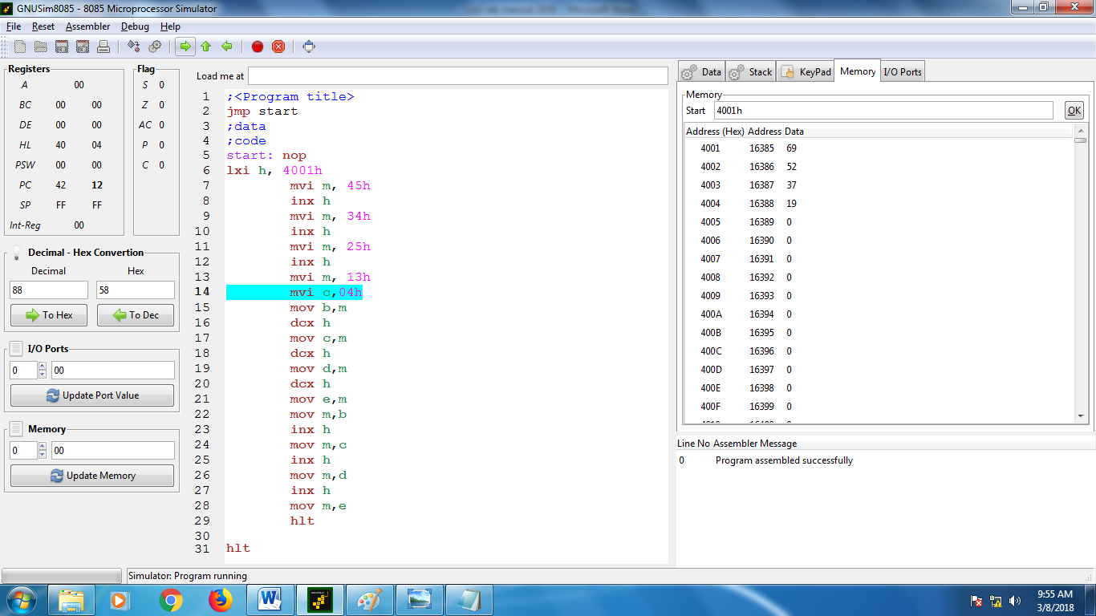

VALUES STORED AT LOCATION 4001, 4002, 4003 AND 4004

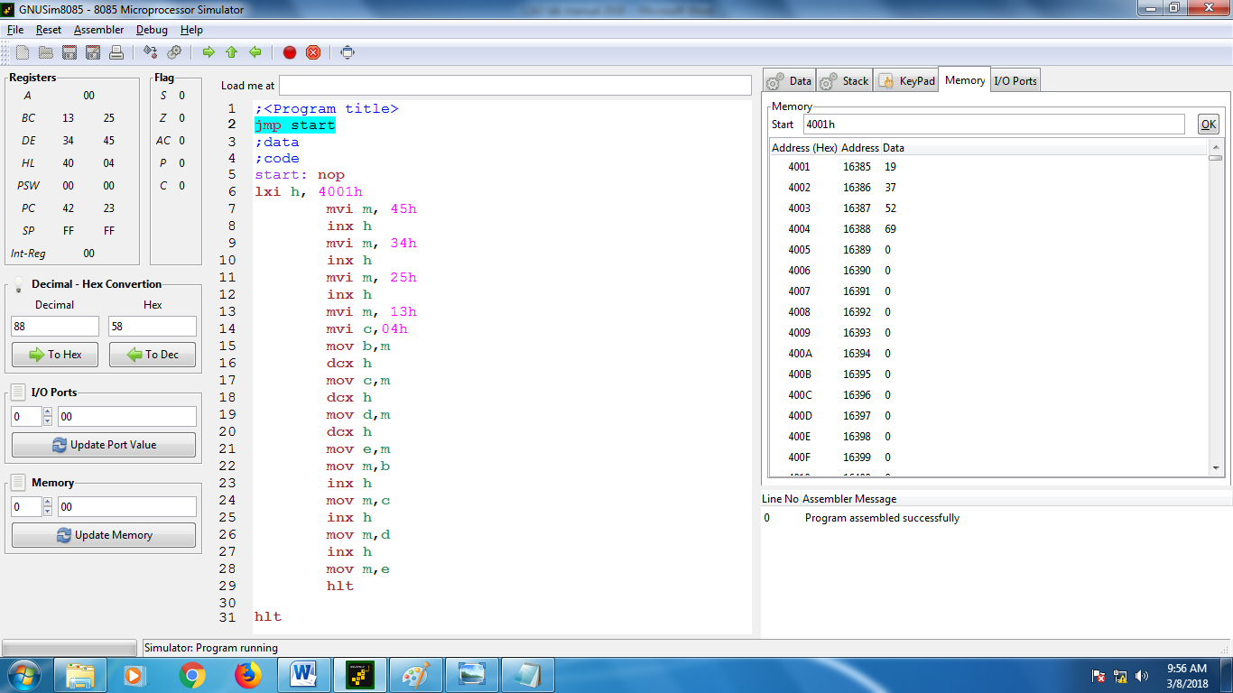

VALUES AT LOCATION 4001, 4002, 4003 AND 4004 AFTER REVERSAL

- addition of two numbers using lxi

lxi h, 2004H
mvi m, 46h
lxi h, 2005h
mvi m, 25h
mov a,m
inx h
mov b,m
add b
hlt

Sample Output:

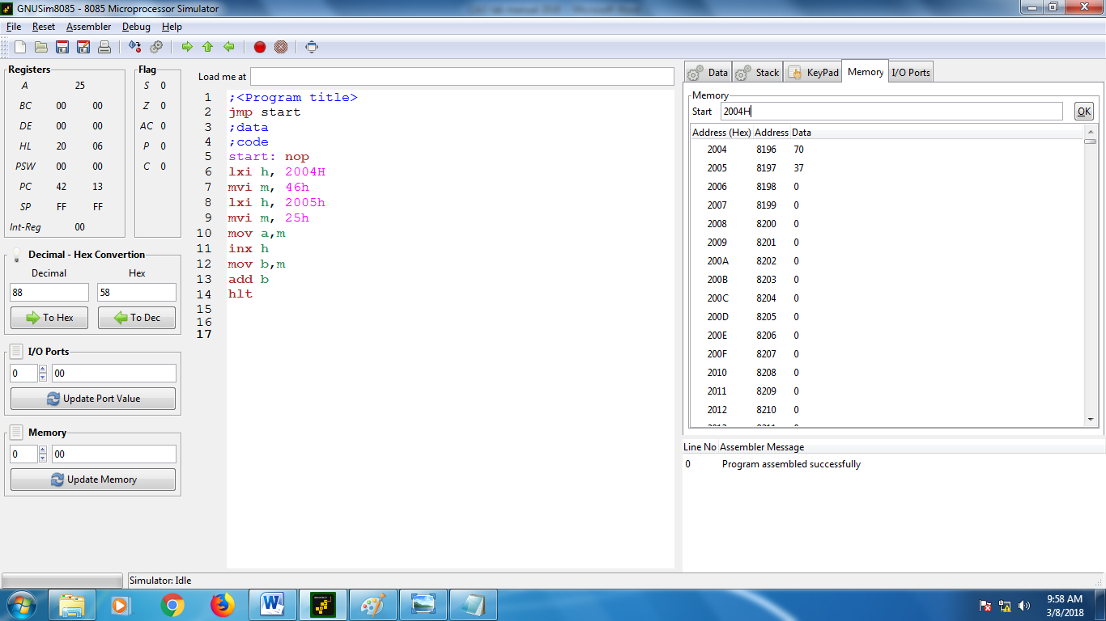

- Factorial of a number

mvi b, 04h //LOADS THE REGISTER B WITH THE VALUE 04H. IT CONTAINS THE //VALUES WHOSE FACTORIAL IS TO BE CALCULATED

mov c,b //LOADS THE REGISTER C WITH THE VALUE IN REGISTER B

dcr c //DECREMENTS THE VALUE IN REGISTER C
loop1: mov e,c //MOVES THE CONTENTS OF C TO REGSITER E
sub a // SUBTRACTS THE VALUE IN ACCUMULATOR, MAKING THE //ACCUMULATOR TO ZERO VALUE
loop2: add b //ADD THE VALUE IN REGISTER B TO THE ACCUMULATOR
dcr e //DECREMENTS THE VALUE OF REGISTER E.
jnz loop2 //CHECKS THE VALUE IN THE REGISTER E, IF IT’S VALUE IS A NON //ZERO VALUE THE CONTROL WILL GO TO loop 2, ELSE IT WILL GO //TO NEXT INSTRUCTION.
mov b,a //LOADS THE REGISTER B WITH THE VALUE IN ACCUMULATOR
dcr c //DECREMENTS THE VALUE IN REGISTER C
jnz loop1 //CHECKS THE VALUE IN REGISTER C. IF IT’S NON ZERO VALUE THE //CONTROL WILL GO TO loop1, ELSE IT WILL GOT TO NEXT //INSTRUCTION.
sta 00h //THE VALUE IN THE ACCUMULATOR IS STORED IN 00H MEMORY //LOCATION
hlt

Sample Output:

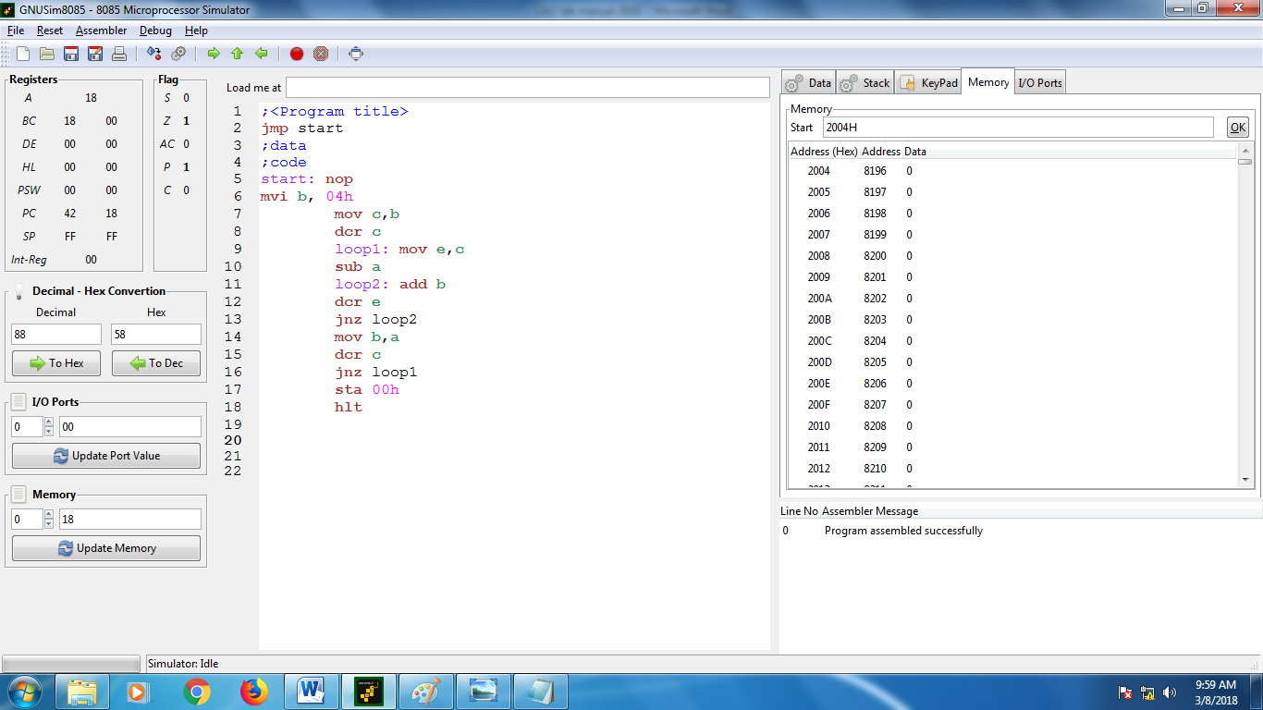

- TO FIND THE LARGEST NUMBER FROM THE SET OF FIVE NUMBERS STORED IN CONTIGENOUS MEMORY LOCATIONS

lxi h,4001h
mvi m,46h
inx h
mvi m,59h
inx h
mvi m,52h
inx h
mvi m,42h
inx h
mvi m,58h
mvi c,05h
step1: movd,a
movb,m
step2: dcx h
mova,m
cmp b
jnc step1
dcr c
jnz step2
hlt

Sample Output:

